Scientific Tools and Measurement
Day 5
Points of View: Tools of the Trade
You will work to show what you’ve learned about scientific tools and measurement from several different viewpoints.
1. Review the lesson from your Ohio Science Fusion Student Edition Pages 34-45.
2. Complete your assignment, and practice presenting your work. You could be asked to present your perspective to your class when you return school.

 | Vocabulary Make a picture dictionary that defines and describes vocabulary terms from this lesson, along with other important words related to scientific tools and measurement. Include a diagram or illustration for each word.
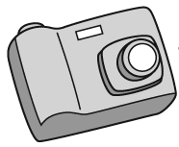 | Examples Take several photos that show a measurement being taken with the proper tool. Then write or draw descriptions that explain what the measurements can tell us and how information from them can be used.
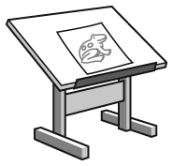 | Illustrations Draw diagrams that explain five different properties that scientist measure. Be sure to include the SI unit that is used to tell about the property and which tool is used to measure it. Note whether the unit is a base unit or a derived unit.
 | Analysis Select an object from your home or nearby area, or choose an event you’d like to study. Record both qualitative and quantitative observations to describe the object or the event.
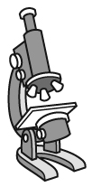 | Measurement Gather various tools from the classroom used to measure length (e.g. a 30 cm ruler, calipers). Measure the diameter of a coin. Make a table for the whole classroom, listing each tool. Each student will use a tool and record their measurement. Switch tools with another student and repeat, recording your own measurement in the table under the appropriate tool, whether or not it is the same as somebody else’s measurement. Compare the precision and accuracy of the readings afterward. You may need to go over what distinguishes precision and accuracy. Explain how these differences could affect the outcome of a scientific investigation.
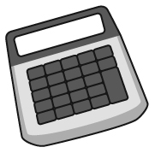 | Calculations Look up at least five measurements that describe very small or very large values, such as something very large or small, or something very far away. Make sure the value is given in SI units. If the measurement is given in standard notation, convert the value to scientific notation. If it is given in scientific notation, have student convert to standard notation and apply SI prefixes (if appropriate) to the numbers.

